PLACES TO GO FOR ICE CREAM!!!

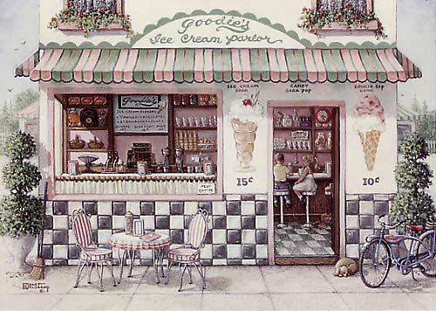

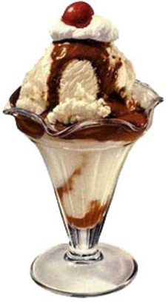

Gazebo  30 Portland Rd.  Bridgton, ME 04040  207-647-2231 | The Scoop  Rt. 302  Bridgton, Me 04040  4 miles from town heading toward Shawnee Peak Ski Mt. on right. | Crystal Lake Dairy Bar  103 Norway Rd.  Harrison, Me 04040  207- 583-2200
Gunnar’s General Store & Ice Cream  109 Main St.  Brownfield, Me  207-935-4862 | Pear's Ice Cream & Hoagie Shop  974 Meadow Road  Casco, ME 04015  207- 627-6002 ‎ | Raymond’s Frozen Custard  605 Roosevelt Tr.  Casco, Me 04015  207-655-1116
Steamboat Landing Minature Golf & Ice Cream Parlor  Rt. 114  Naples, ME 04055  207- 693-6782 | Naples Dairy Bar  894 Roosvelt Trail  Naples, ME 04055  207- 595-8746 ‎ | Froagies Ice Cream  Bridgton Rd (Rt. 302)  Fryeburg, ME 04037  207- 935-2669
Friendlys Ice Cream Shop  789 Roosevelt Trail  Windham, ME 04062  207- 893-2740 | Dairy Queen  753 Roosevelt Trail  Windham, ME 04062  207- 892-9727 | Ice Cream Dugout  3 Storm Dr  Windham, ME 04062  207- 894-7769
Ruby Rose Frozen Custard  1184 Main St.  Poland, Me 04274 | Shaner’s Family Restaurant  193 Main St.  South Paris, Me 04281  207-743-6367 | Cold Stone Creamery  1500 White Mountain Highway  N. Conway, NH 03860  603-356-2223
Abbott's Premium Ice Creams  230 E. Conway Rd  Center Conway, NH 03813  603-356-2344 | Ben & Jerry’s Scoop Shop  26 Norcross Circle  N. Conway, NH 03860  603-356-7720 | Melby’s Market and Eatery  927 Valley Road,  Waterford, ME 04088  207- 583-4447 ‎

